 | 9.3.2 Editors - UV Editor - Sidebar - Tools Tab
Table of content
Grab Relax and Pinch Brush tools 1
Brush Panel 2
Browse Brush 2
Custom Icon 2
Edit Box 2
Brush Settings Panel 3
Radius 3
Strength 3
Relax 3
Falloff 3
Custom falloff panel 3
Navigation elements 3
Zoom in and out 4
Tools 4
Reset View 4
Vector Handle 4
Auto Handle 4
Auto Clamped Handle 4
Reset Curve 4
Use Clipping 4
Delete Points 4
Curve window 4
Curve Presets 4
Options Panel 4
Lock Borders 5
Sculpt all Islands 5
Display Cursor 5

Grab Relax and Pinch Brush tools

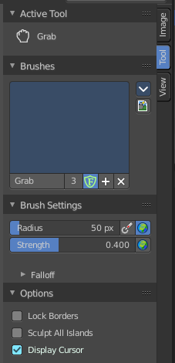
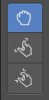
Grab Relax and Pinch tools are drawing tools. And shows some brush related settings when activated. They are equal. Only the Pinch tool shows some extra settings for the relax method.

Brush Panel

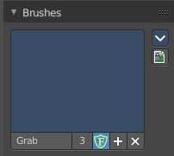
The Brush Panel contains the different brushes. It is in case of Grab Relax and Pinch tools pretty meaningless. Those tools just have a radius, not a brush. But the brush system is global, and reused in this place here.

Browse Brush
The big image at the top is a drop down box where you can see the current active brush. You can add duplicates of this active brush, and customize it to your needs. But the active brush gets chosen in the Tool Shelf at the left of the 3D View.
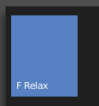
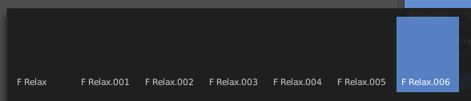
When you have added a few more brushes then the drop down box may be more than full. You will see some little white arrows then. Either in the top left or in the bottom right corner. They indicate that some brushes are hidden before or after the current display.
To scroll to this hidden content use the mouse wheel, or the arrow up and down buttons at the keyboard.

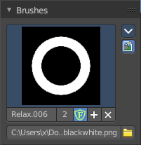
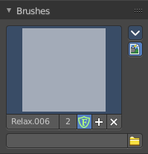
Custom Icon
Clicking at the custom icon button reveals an edit box to choose a custom icon for the currently active brush.

Edit Box
The edit box below the Image shows you the name of the current active brush.
The number right of it, in this case 2, indicates how much number of users ( internally ) this brush uses. This means that this data block (the brush) shares currently settings with at least one other object. Most probably the parent brush where we have created it from. Click at the value to make this brush a single user. The button will vanish then.
Fake user set the brush to have a fake user. Zero user data-blocks are normally not saved. But sometimes you want to force the data to be kept even when the data block has no user.
The + button allows you to add a new pencil with the current settings. Note that the brushes are NOT saved when you close Bforartists. You can save them into the current blend file. Or you can save the startup file. But be careful here. This saves everything else of the current state of Bforartists too.
The X button deletes the brush as the active one. It does NOT delete it from the brushes list.

Brush Settings Panel

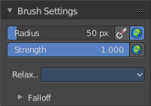
Radius
The radius of the brush.
The first button behind the edit box enables tablet pressure sensitivity for radius.
The second button is to adjust if the brush radius uses and changes the global radius values. Or if the radius is just adjusted locally for the current tool set.

Strength
How powerful the effect is applied.
The button behind the edit box is to adjust if the brush strength uses and changes the global strength values. Or if the strength is just adjuster locally for the current tool set.

Relax
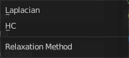
Choose another relaxation method. Default is Laplacian.

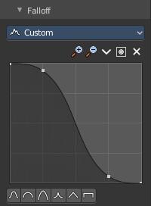
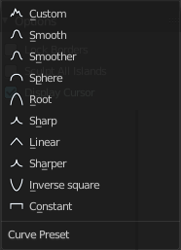
Falloff
Adjust the falloff method of the brush. The drop down box at the top allows you to choose between predefined falloff methods. The method Custom allows you to create your own falloff curve.

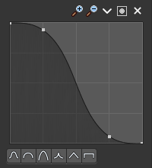
Custom falloff panel

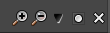
Navigation elements
The navigation elements at the top are described from left to right.

Zoom in and out
The two buttons with the magnifying glass at it zooms in and out in the curve window.

Tools
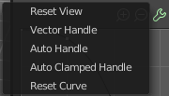
Tools is a menu where you can find some curve related tools.

Reset View
Resets the curve windows zoom.

Vector Handle
Set handle type to Vector.

Auto Handle
Set handle type to Auto.

Auto Clamped Handle
Set handle type to Auto Clamped.

Reset Curve
Resets the curve to the initial shape.


Use Clipping
Clipping options. Set up clipping for the stroke.

Delete Points
Deletes selected curve point.

Curve window
Tweak and adjust the falloff curve by clicking at a curve point and dragging it around.
Double click adds a new point.
Holding down ctrl activates temporary snapping.
Holding down shift enables slower movement, which allows more accurate setting.


Curve Presets
Predefined curve presets.

Options Panel

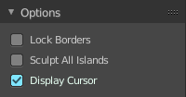
Lock Borders
Disable editing of boundary edges.

Sculpt all Islands
Brush operates on all islands.

Display Cursor
Displays the cursor at drawing.

